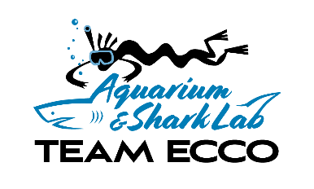
511 N Main St Hendersonville, NC 28972 www.teamecco.org 828 692 8386

Date received by Team E.C.C.O. ____/_____/ 2024
_
SEA GROUP visit form 2024 (forms are acknowledged on a first come first served basis)
Please read carefully, fill in all highlighted areas, and return via email to
Person making request: phone: Email: Name of group: From: organization/school/family/church/other
City: County: State:
Visit request date options on:
___/___/_2024 @ ____pm W / TH / F / S OR /___/_2024 @ ____pm W / TH / F / S
Special requests or notes: ______________________________
Will there be any special needs individuals with group? YES NO This information helps us prepare.
Please initial at each line
I understand that visit is for the above requested day/date and time once confirmed by Team ECCO.
I understand that group visits do not include any special materials or programs.
I will call 828 692 8386 to make pre-payment. Prepayment must be received to confirm group.

Pricing: $6.50 for all guests ages 5 years and up entering with group
$ 4.50 for all guests ages 1-4 years old entering with group

# under 1 year= # aged 1-4 # aged 5 and older

TOTAL NUMBER IN GROUP
Please note that:
General admission groups are in the Aquarium with the general public. Programs and private group amenities are not provided.
Group must have a minimum of 8 visitors who would attend at the 5yrs and older admission price of $7.50.
Group is not confirmed until payment has been received by Team E.C.C.O.
You must bring your pre-paid receipt for admission

Our in-tank shark and sting ray feed is at 1:30 pm and 3:15 W/ Th / Fr / Sat.

Signed print name

Relationship to group

Please make notes here:

